HDB Resale ETL Pipeline - Team Midjoiners

Mini Table of Contents
- Project Overview
- Team Roles and Responsibilities
- Project Folder Structure
- Phase 1 — Extract & EDA
• 4.1 Extract Process
• 4.1.1 Challenges & Workarounds
• 4.2 Exploratory Data Analysis (EDA)
• 4.2.1 Objectives
• 4.2.2 EDA Findings
• 4.2.3 SQL EDA Equivalents
• 4.2.4 EDA Summary
• 4.2.5 Challenges & Workarounds
- Phase 2 — Transform
• 5.1 Cleaning Rules
• 5.2 Feature Engineering
• 5.3 Treatment of _id
• 5.4 Derived Categories
• 5.5 Output Schema
• 5.6 Validation Checks
- Phase 3 — Load (PostgreSQL)
• 6.1 PostgreSQL Setup
• 6.2 Table Schema
• 6.3 Load Process
• 6.4 Verification
• 6.5 Challenges & Workarounds
• 6.6 Rationale for Single Table Design and Future Expansion
- Phase 4 — SQL Layer & Views
• 7.1 Purpose
• 7.2 Data Integrity Queries
• 7.3 SQL EDA Queries
• 7.4 Analytical Views
• 7.5 Storytelling Foundations
- Phase 5 — Storytelling (SQL Only)
• 8.1 Overview
• 8.2 Challenges & Workarounds
• 8.3 Comparison Queries
• 8.4 Observations
• 8.5 Final Takeaway Narrative
- Phase 6 — Future Improvements
- Appendix
• Data Dictionary

1. Project Overview
This project builds an end to end ETL (Extract, Transform, Load) pipeline for the Singapore HDB resale dataset (2017 onwards).
The goal is to:
- Extract the latest resale transaction data
- Clean and enrich it using defined business logic
- Load it into PostgreSQL
- Run SQL quality checks
- Build analytical SQL views
- Present insights using SQL query outputs
This interim project is limited to SQL only (no Power BI), so storytelling will be performed entirely with SQL outputs and screenshots.

2. Team Roles & Responsibilities
Member | Role | Responsibilities
Member A (Alvin) | Extract + EDA Lead | API extraction, raw data verification, exploratory data analysis, identification of anomalies, proposing transform logic, defining engineered fields, EDA SQL equivalents
Member B  (Boon) | Transform Lead | Data cleaning, type conversions, applying business rules, computing engineered features, ensuring processed dataset quality
Member C  (Janson) | Load Lead | PostgreSQL setup, database and table creation, defining schema + constraints, loading processed data, load verification
Member D  (Peisi) | SQL Layer Lead | Data integrity SQL checks, analytics queries, creation of SQL Key Insight views, ensuring naming consistency, producing insights using SQL

3. Project Folder Structure
project_root/
│
├── data/
│ ├── raw/resale_flat_prices_2017_onwards.csv
│ └── processed/resale_flat_prices_2017_onwards_clean.csv
│
├── notebooks/
│ ├── 00_download_hdb_resale_from_api.ipynb
│ ├── 01_eda_hdb.ipynb
│
├── sql
│ ├── dataintegrity.sql
│ ├── EDA.sql
│ ├── analysisqueries.sql
│ └── storytelling.sql
│
├── scripts/
│ ├── etl_transform.py
│ ├── config.py
│ ├── connection.py
│ ├── create_db.py
│ ├── create_table.py
│ ├── etl_load.py
│ ├── etl_extract.py
│ ├── schema.py
│ ├── hdb_etl_pipeline.py
│ └── .env

4. PHASE 1 — EXTRACT + EDA

4.1 Data Source (API Extract)
Dataset: HDB Resale Flat Prices (2017–present)
Source: Data.gov.sg public API
Extraction was done using a Python notebook:
- 00_download_hdb_resale_from_api.ipynb
Key steps:
- Query the API endpoint for all records from 2017 onward
- Paginate through all results
- Save output as raw CSV into data/raw/
- Validate the presence of expected fields
- Check row counts and schema consistency
Download artifacts:
- resale_flat_prices_2017_onwards_raw.csv
4.1.1 Challenges & Workarounds
Challenge 1:
Manual downloading introduces human error.
Extraction notebook documents every step, including timestamped output, file size check, and save path validation. Even though the extraction is semi-automated, the steps are consistent and repeatable for all team members.
Challenge 2:
Large queries (multi-year data) can trigger API throttling.
A semi-automated CSV download was used from the static endpoint. This reduces dependency on unstable network/API calls and improves extract reproducibility.

4.2 Exploratory Data Analysis (EDA)
Notebook: 01_eda_hdb.ipynb

4.2.1 Objectives
- Understand dataset structure
- Identify anomalies and cleaning requirements
- Explore key variables to inform the Transform phase
- Determine new engineered fields needed for SQL storytelling
Challenges & Workarounds

4.2.2 EDA Findings

A. Data Quality Observations
- No missing values in core columns (town, flat_type, resale_price).
- Some derived fields (e.g., remaining_lease) require conversion from a text format (“61 years 04 months”).
- No duplicate rows detected after checking natural key combinations.

B. Feature & Column Transform Needs
EDA revealed the need for:
- remaining_lease_years → numeric years
  - EDA identified the need to compute numeric values for trend analysis and SQL filtering
  - SQL queries such as “remaining lease < 60 years” cannot be done on text format.
- remaining_lease_months → numeric months

- flat_age_years and flat_age_category → based on lease commencement
- resale_quarter → for time grouping
- Normalised price_per_sqm
- Cleaned month → converted to DATE format (YYYY-MM-DD)
These insights guide the transformation logic in Phase 2.

4.2.3 SQL EDA Equivalents
Since SQL is the final storytelling tool, all EDA visuals were also expressed as SQL.

1. Average resale price by flat type
SELECT flat_type, ROUND(AVG(resale_price), 0) AS avg_resale_price
FROM hdb_resale_transactions
GROUP BY flat_type
ORDER BY avg_resale_price DESC;

2. Number of transactions by year

SELECT resale_year, COUNT(*) AS num_transactions
FROM hdb_resale_transactions
GROUP BY resale_year
ORDER BY resale_year;

3. Monthly price trend

SELECT DATE_TRUNC('month', month) AS month_start,
ROUND(AVG(resale_price), 0) AS avg_resale_price
FROM hdb_resale_transactions
GROUP BY 1
ORDER BY 1;

4.2.4 EDA Summary
- Transaction volume varies year to year, peaking in certain post-COVID periods.
- Prices show a clear upward trend, especially after 2020.
- 4 ROOM flats form a large portion of the dataset and are ideal for storytelling.
- Towns like Sengkang, Punggol, and Tampines dominate transaction volume.
- Executive and 5 ROOM flats exhibit the highest price ranges.

These findings justify the SQL views chosen in later phases.
Some analytical and validation queries are implemented only in SQL to support the Load and storytelling phases. Additional SQL-only queries, such as the number of transactions by year, were included to support load verification and provide numerical context for the analysis. These SQL extensions complement the EDA without requiring changes to the EDA notebook.
4.2.5 Challenges & Workarounds
Challenge 1:
Masked data issues not visible until deeper checks. For example, Columns like remaining_lease look clean at first glance but hide quality issues such as inconsistent formatting or missing month values.
EDA included text pattern checks, data type probing, and custom parsing functions to detect anomalies early before transformation.
Challenge 2:
Visual EDA vs SQL EDA mismatch. Matplotlib or seaborn charts show trends visually, but SQL storytelling requires numeric summaries.
Every visual trend discovered in the notebook was converted into SQL equivalent queries. This keeps the SQL layer aligned with EDA findings.

5. PHASE 2 — TRANSFORM
5.1 Cleaning Rules
The goal of the transformation was to clean, standardize, and enrich the dataset for analysis, visualization, and modeling purposes.
5.1.1 Raw Data Structure
The raw dataset contains the following columns:
Column Name | Description
_id | Unique identifier for each record
month | Year-month of resale (YYYY-MM)
town | Town/estate where the flat is located
flat_type | Type of flat
block | Block number
street_name | Street name of the flat
storey_range | Floor range of the flat
floor_area_sqm | Floor area in square meters
flat_model | Model of the flat
lease_commence_date | Year the lease started
remaining_lease | Remaining lease duration in years and months
resale_price | Resale price
5.2 Data Transformation Steps
5.2.1 Data Cleaning
- Missing Values Check:
Checked for missing values in all columns. None were found in this sample.
- Duplicate Columns Check:
After drop the ‘_id’ column, checked for duplicate rows and found 307 rows data duplicated. All the duplicated rows are removed.

5.2.2 Feature Engineering
- Drop the ‘_id’ column as it is not required. After drop we can notice some data are duplicate.
- From ‘month’ column, create a three new column, ‘year’, ‘month’ and ‘quarter’
- Converted ‘lease_commence_date’ to new column ‘remaining_lease_year’ as integer, only indicate the year.
- Generate a new column ‘price_per_sqm’ from floor_area_sqm and resale_price as numeric types.
- Generate a new column ‘flat_age_year’
5.3 Derived Categories
- Generate two categories ‘flat_age_catergory’ and ‘price_category’.
  - ‘flat_age_category’ classify the flat age to New, Young, Middle-aged, Mature, Old. This classification will help determine the flat age in a clear way.
  - ‘price_category’ classify the price range in Low, Middle and High. This enable a clear view of the price range.
- Generate a ‘region’ column, that classify the town into the region they belong to.

5.4 Output Schema
Column Name | Data Type | Transformation Applied
_id | Integer | Remove
month | String | datetime
Town | String | Preserved
flat_type | String | Preserved
block | String | Preserved
street_name | String | Preserved
storey_range | String | Preserved
floor_area_sqm | Float | Preserved
flat_model | String | Preserved
lease_commence_date | Integer | Preserved
remaining_lease | String | Preserved
resale_price | Float | Preserved
resale_year | Integer | Convert from month
resale_month | Integer | Convert from month
resale_quarter | Integer | Convert from month
remaining_lease_years | Integer | Calculated from remaining_lease
flat_age_years | Integer | Calculated: resale_year - lease_commence_date
price_per_sqm | Float | Calculated: resale_price / floor_area_sqm
flat_age_category | String | NEW - Derived from flat_age
price_category | String | NEW - Derived from resale_price
region | String | NEW - Mapped from town

5.5 Validation Checks
- Validate floor_area_sqm values are in correct range
- Validate resale_price in correct range
- Validate lease_commence_date is valid
- After clean, total have 220289 rows, 20 columns

6. PHASE 3 — LOAD

6.1 PostgreSQL Setup
- Database Creation:
  - PostgreSQL database named “hdb_resales_db” was created using pgAdmin or Python script.
  - Connection parameters (host, port, database name, username, password) are stored securely in environment variables and accessed via “connection.py” script.
- Tools Used:
  - pgAdmin: for initial database setup and schema inspection.
  - Python – Programming language to control the ETL process.
  - Python (SQLAlchemy): Python library act as a bridge for connecting to PostgreSQL database, define table schema, and run SQL queries from python.

6.2 Table Schema
- Target Table: “resales_prices”
- Schema: Define in “schema.py”
- Columns (based on resale dataset):
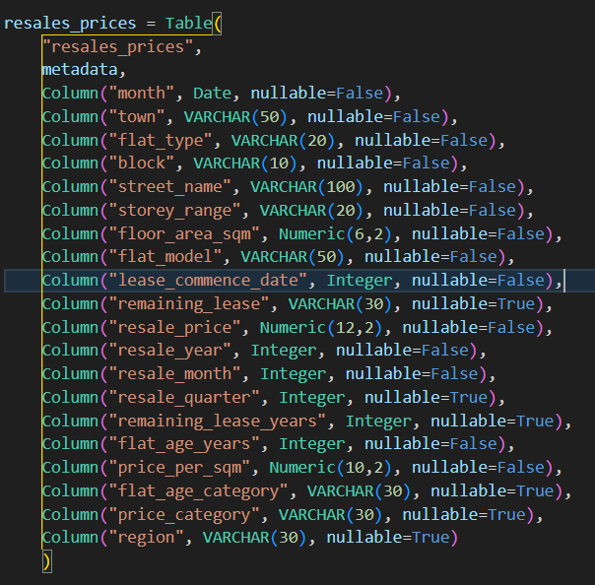

6.3 Load Process
- Process:
  - The “etl_load.py” script connects to PostgreSQL database using Python SQLAlchemy library.
  - Data read from processed CSV file in chunks (5000 per batch) to optimize memory usage
  - Each chunk is aligned with the table schema and inserting using “pandas.DataFrame.to_sql()”.
- Automation:
  - Python Logging library is used to track progress and errors.
  - Progress bar (Python tqdm) provide visibility during loading of large data.
- Advantages:
  - Efficient in handling of large datasets
  - Pre-define schema alignment ensures columns consistency.
  - Reuseable modules for future datasets.

6.4 Verification
- Row count verification
  - After loading, a query is executed:
  - 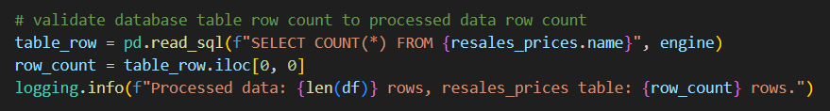
  - The result is compared against the number of rows in the processed CSV data to confirm completeness.
Summary
- PostgreSQL is setup with secure connection handling.
- A pre-defined schema enforces data integrity.
- Data is inserted efficiently via Python scripts.
- Verification query will ensure both row count correctness.
Script | Purpose
config.py | Stores configuration settings
connection.py | Create PostgreSQL connection using env variables
schema.py | Define target table schema (column names + types)
create_db.py | Create database if not exists
create_table.py | Create table structure using schema
etl_load.py | Load cleaned CSV into the table

6.5 Challenges & Workarounds
During the development of the ETL pipeline (Extract + Load process), several technical and workflow challenges were encountered. This section record the issues and the solutions implement to overcome them.
- File path handling
  - Issue: Confusion between relative paths (../data/…) and absolute paths (Path(__file__)).
  - Solution: Standardized on pathlib.Path for consistent, cross-platform resolution.
- Table failed to create
  - Issue: Running the “create_table.py” did not result in a table being created in PostgreSQL.
  - Solution: Inserted “connection.commit()” after the table creation statement to ensure changes are saved permanently in the database. (Without “connection.commit()” PostgreSQL rolled back the transaction when the connection closed).
- Repeated code spread across multiple scripts:
  - Issue: Code duplication across multiple scripts led to messy and hard to maintain code.
  - Solution: Refactored common logic (database connection) into a separate utility file. Import these functions, or configurations in each script to ensure consistency and reducing duplication.
- Table schema not properly define
  - Issue: Table schema was not pre-defined, resulting in columns being generated directly from the processed CSV file.
  - Solution: Created a schema definition file (schema.py) to enforce columns name, data types. The ETL pipeline now aligns data with this schema before loading.

6.6 Rationale for Single Table Design and Future Expansion
This project uses a single source dataset, the HDB Resale Flat Prices dataset from Data.gov.sg. Since the dataset is already delivered in a fully denormalized, analysis ready structure, one table is acceptable and appropriate.
- Why one table is acceptable:
  - The dataset is already delivered as a clean, denormalized, single file.
  - No additional lookup datasets exist.
  - Categorical fields have low cardinality and do not require normalization.
  - Simplifies ETL for learning and prototype purposes.
- How future enhancements could split into multiple tables:
  - Introduce fact and dimension tables (star schema).
  - Reduce duplication by extracting towns, flat types and dates into dimension tables.
  - Improve query performance and indexing.
  - Prepare for integrating additional datasets in the future.

7. PHASE 4 — SQL LAYER & VIEWS
7.1 Purpose
- Connected to postgresql using sqlalchemy library in Jupyter notebook
- Created tables using the python script that was loaded
- Run analytical queries on the cleaned dataset
- Standard SQL queries to check if data imported is not corrupted with no null values
- EDA queries to ensure output matches the EDA notebook output
- Filtering guidelines e.g. 4 Room units and transactions from year 2023 onwards
  - ‘4 Room’ units were selected because they are the most populous size of hdb flat
  - Prices rose sharply from 2023 after Covid ended.
- Performed analytical queries by way of storytelling, of a fictional family looking to upgrade their current hdb flat and the queries made on HDB data set to find out relevant information to guide housing decisions. (Refer to Phase 5 for more details)
The SQL layer includes several queries that do not appear in the EDA notebook. This is intentional. The EDA notebook focuses on price trends and exploratory visuals to guide the Transform phase, while the SQL layer also serves additional purposes such as load verification, data completeness checks, and numerical summaries that are easier to perform in SQL.
Queries like “Number of transactions by year” provide essential context and validation for the loaded dataset, even though they are not visualized in the Python EDA.
This separation ensures clarity of purpose: EDA supports transformation decisions, while SQL provides structural validation and analytical robustness for the interim presentation.
Subsections:
- 7.2 Data Integrity Queries - To check if the data queried is valid and imported correctly
- 7.3 SQL EDA Queries
-- Average resale price by flat type
SELECT flat_type, ROUND(AVG(resale_price), 0) AS avg_resale_price
FROM hdb_resale_transactions
GROUP BY flat_type
ORDER BY avg_resale_price DESC;
-- Number of transactions by year
SELECT resale_year, COUNT(*) AS num_transactions
FROM hdb_resale_transactions
GROUP BY resale_year
ORDER BY resale_year DESC;
-- Monthly price trend (To show the prices are rising over time especially after 2020)
SELECT DATE_TRUNC('month', month) AS month_start, ROUND(AVG(resale_price), 0) AS avg_resale_price
FROM hdb_resale_transactions
GROUP BY 1
ORDER BY 1;
- 7.4 Analytical Views - Sample query views on what people might be searching for when looking for hdb homes
-- What is the average resale price for flats recently MOP?
CREATE VIEW mop_avg_price AS
SELECT town, flat_type, ROUND(AVG(resale_price), 2) AS average_resale_price
FROM hdb_resale_transactions
WHERE lease_commence_date = 2021 AND
flat_type IN ('3 ROOM', '4 ROOM', '5 ROOM') AND
flat_model != 'DBSS'
GROUP BY town, flat_type
ORDER BY average_resale_price DESC
SELECT * -- Create view for average prices for recently MOP flats
FROM mop_avg_price
-- What is the percentage increase from MOP flat prices 1 year ago from most recent MOP flats
CREATE VIEW price_increase_percentage_mop_since_2020 AS
SELECT town,
flat_type,
ROUND((MAX(resale_price) - MIN(resale_price)):: numeric / MIN(resale_price) * 100, 2) AS increase_in_price
FROM hdb_resale_transactions
WHERE flat_type IN ('3 ROOM', '4 ROOM', '5 ROOM') AND
flat_model != 'Terrace' AND flat_model != 'DBSS' AND
lease_commence_date >= 2020
GROUP BY town, flat_type
ORDER BY increase_in_price DESC
SELECT * -- Create view for % price increase for most recent MOP flats to 1 year ago
FROM price_increase_percentage_mop_since_2020

- 7.5 Storytelling Foundations
A fictional family’s journey in finding their perfect home using a cleaned hdb data set with added columns such as ‘region’, ‘ price_per_sqm’, ‘flat_age_category’
  - Profile of couple - The Lims, a couple in their late 30s with a young child of 4 years old are looking to upgrade from a 3 room flat in Jurong East to a 4 room flat in Clementi to be near a variety of good schools as they plan to have another child. With a budget of around 750k-780k in mind, they are doing research to find out if this budget is feasible for their dream home in Clementi
    - 1st objective - Find out how much an average 4 room cost in Clementi
    - 2nd objective - How much do 3 room flats sell in Jurong East to estimate proceeds receive from selling their flat
    - 3rd objective - If the resale prices for flats in Clementi are within their budget, to start looking for flats with 70 years left OR if it is not within their budget, to look for 4/5 Room flats in their current area.

8. PHASE 5 — STORYTELLING (SQL ONLY)
8.1 Overview
This phase demonstrates how SQL insights support real life decision making. The Lims explore affordability, price trends, and lease considerations using interpreted SQL results.
• Objective 1: Ideal home in Clementi
• Objective 2: Selling their current Jurong East flat
• Objective 3: More affordable alternatives
• Objective 4: Price comparison over time

8.2 Challenges & Workarounds
  - Tried to connect a graphical application to Postgresql like Google Looker Studio to input the queries in charts but unable to connect due to a common error encountered by other users in forums
  - Have to abandon the idea for now due to constraint of time

8.2 Screenshots of query + output + row counts
==========================================================
-- Objective: How much would their ideal home cost for a 4 Room flat in popular Clementi estate
-- Average Resale Price in Clementi estate for 4 ROOM flats
-- Shows the average pricing for 4 rooms flats in Clementi transacted in 2025
-- This query provides an estimated budget the couple needs to afford a 4 room in Clementi ==========================================================
SELECT town, ROUND(AVG(resale_price), 0) AS avg_resale_price
FROM hdb_resale_transactions
WHERE town = 'CLEMENTI' AND
flat_type = '4 ROOM' AND
resale_year = 2025
GROUP BY town
CREATE VIEW avg_price_4_room_clementi AS
SELECT town, ROUND(AVG(resale_price), 0) AS avg_resale_price
FROM hdb_resale_transactions
WHERE town = 'CLEMENTI' AND
flat_type = '4 ROOM' AND
resale_year = 2025
GROUP BY town;
VIEW -- Create view for the Avg Price for 4 Room Clementi in 2025
Select *
FROM avg_price_4_room_clementi
SCREENSHOT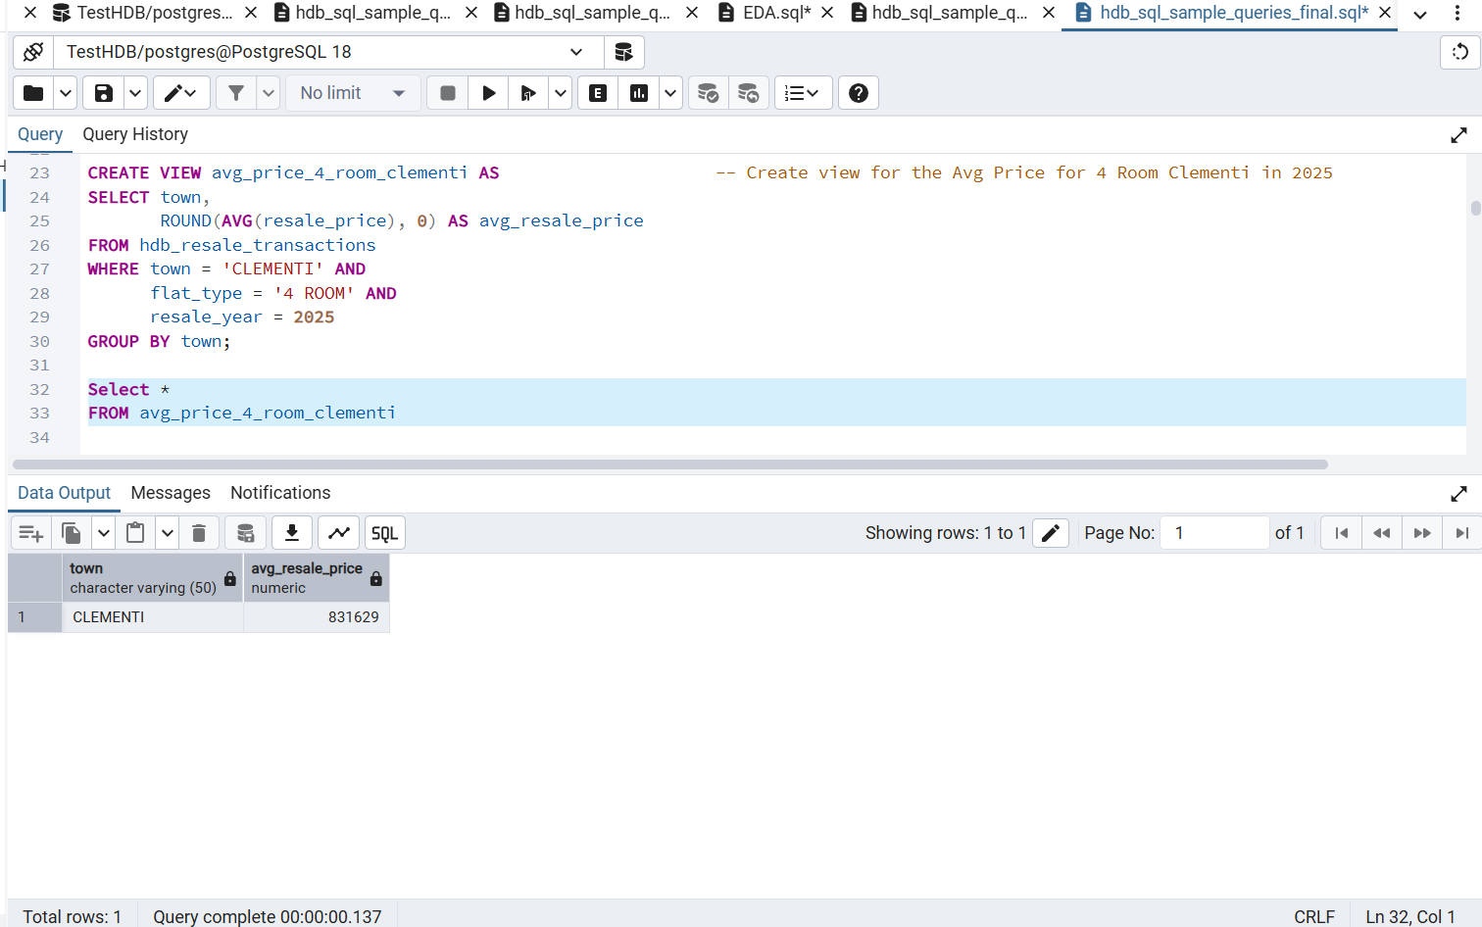

==========================================================
-- Objective: Estimate a selling price for their 3 Room Flat in Jurong East
-- Average Resale Price in Jurong East for 3 Room flats
-- Shows the average price for 3 rooms flats in Jurong East transacted in 2025
-- This query provides an estimated value they could potentially sell their house for ==========================================================
SELECT town, ROUND(AVG(resale_price), 0) AS avg_resale_price
FROM hdb_resale_transactions
WHERE town = 'JURONG EAST' AND
flat_type = '3 ROOM' AND
resale_year = 2025
GROUP BY town
CREATE VIEW avg_price_3_room_jurongeast AS
SELECT town, ROUND(AVG(resale_price), 0) AS avg_resale_price
FROM hdb_resale_transactions
WHERE town = 'JURONG EAST' AND
flat_type = '3 ROOM' AND
resale_year = 2025
GROUP BY town
VIEW -- Create view for the Avg Price for 3 Room Jurong East in 2025
SELECT *
FROM avg_price_3_room_jurongeast
SCREENSHOT
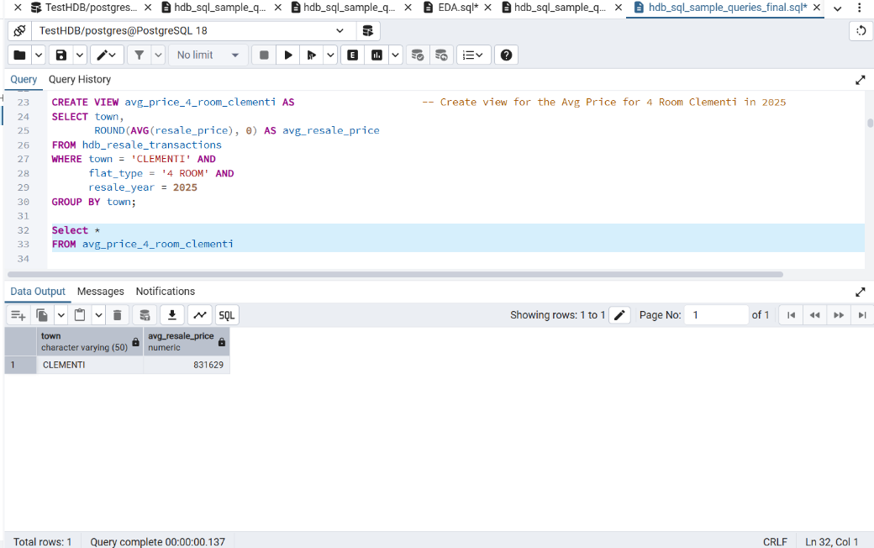
==========================================================
-- Objective: Find a more affordable 4/5 Room hdb flat in their current estate with about 70 lease years left
-- Average Resale Price in Jurong East for 4 Room flats with about 70 lease years
-- Shows the average price for 4-5 rooms flats in Jurong East transacted in Sept 2025 onwards with 70 years left ==========================================================
SELECT town, flat_type, ROUND(AVG(resale_price), 0) AS avg_resale_price
FROM hdb_resale_transactions
WHERE town = 'JURONG EAST' AND
flat_type IN ('4 ROOM', '5 ROOM’) AND
resale_year = 2025 AND
remaining_lease_months > 69 AND
month > DATE '2025-09-01'
GROUP BY town, flat_type
CREATE VIEW avg_price_4_and_5_room_jurongeast AS
SELECT town, flat_type, ROUND(AVG(resale_price), 0) AS avg_resale_price
FROM hdb_resale_transactions
WHERE town = 'JURONG EAST' AND
flat_type IN ('4 ROOM', '5 ROOM') AND
resale_year = 2025 AND
remaining_lease_months > 69 AND
month > DATE '2025-09-01'
GROUP BY town, flat_type
VIEW -- Create view for Avg Price on 4/5 Room Jurong East in 2025 >= 69 lease left
SELECT *
FROM avg_price_4_and_5_room_jurongeast
SCREENSHOT
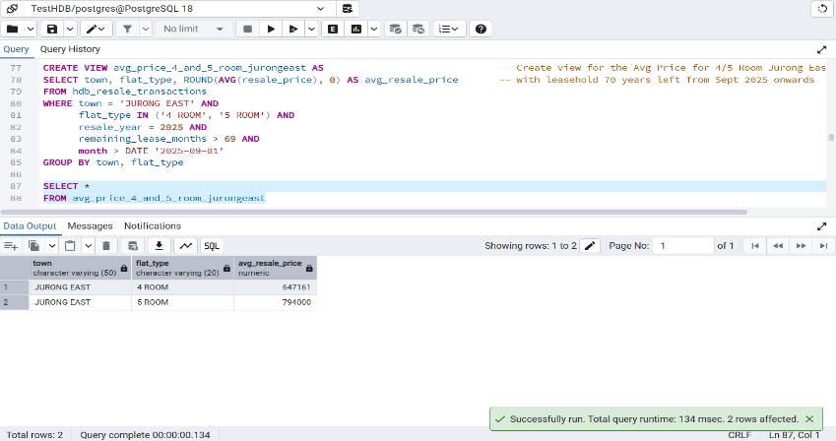

8.3 Comparison Queries (across time periods)
==========================================================
-- Objective: Check if price has increased within the year itself ie from the beginning of the year vs last quarter of year (Sept onwards since we are in Dec now)
-- Average Resale Price in Jurong East for 4 Room flats with about 70 lease years
-- Shows the average price for 4-5 rooms flats in Jurong East transacted at beginning of year vs last quarter with 70 lease years left
-- RESULT - prices rose by at least 10k from the beginning of the year to last quarter of 2025 for both 4 & 5 Room flats
==========================================================
Query 1
SELECT town, flat_type, ROUND(AVG(resale_price), 0) AS avg_resale_price
FROM hdb_resale_transactions
WHERE town = 'JURONG EAST' AND
flat_type IN ('4 ROOM', '5 ROOM’) AND
resale_year = 2025 AND
remaining_lease_months > 69 AND
month > DATE '2025-09-01'
GROUP BY town, flat_type
SCREENSHOT
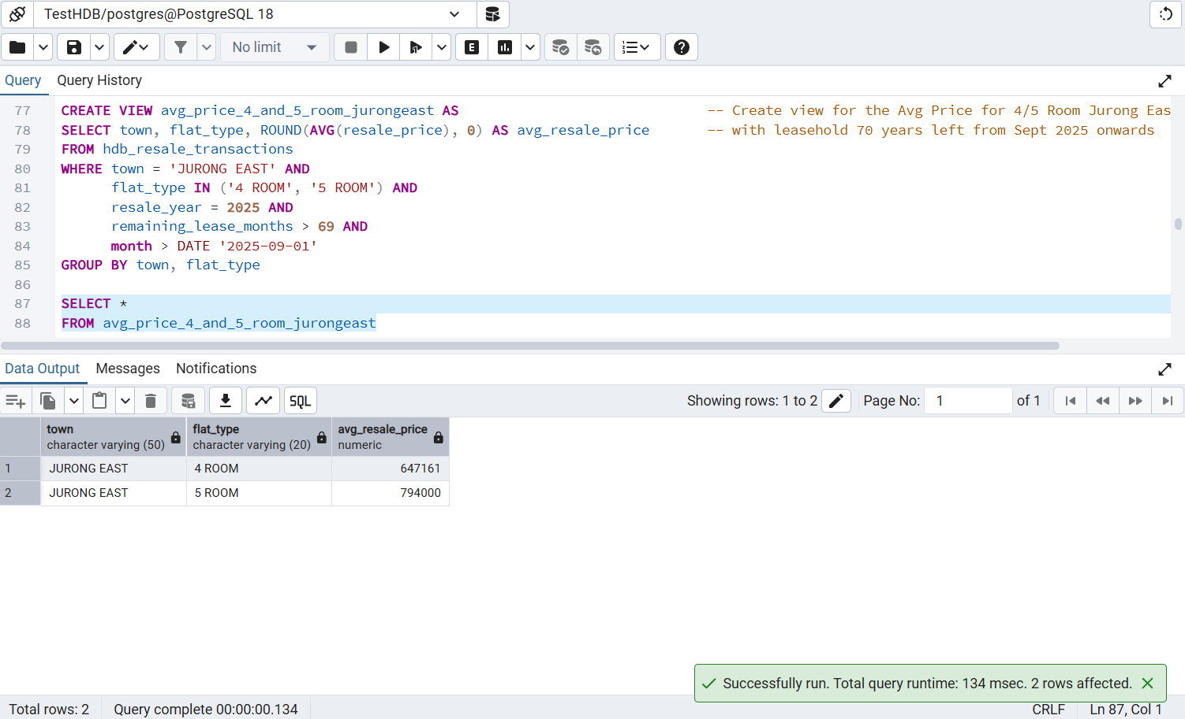
versus
Query 2
SELECT town, flat_type, ROUND(AVG(resale_price), 0) AS avg_resale_price
FROM hdb_resale_transactions
WHERE town = 'JURONG EAST' AND
flat_type IN ('4 ROOM', '5 ROOM’) AND
resale_year = 2025 AND
remaining_lease_months > 69 AND
month >= DATE '2025-01-01'
GROUP BY town, flat_type
SCREENSHOT
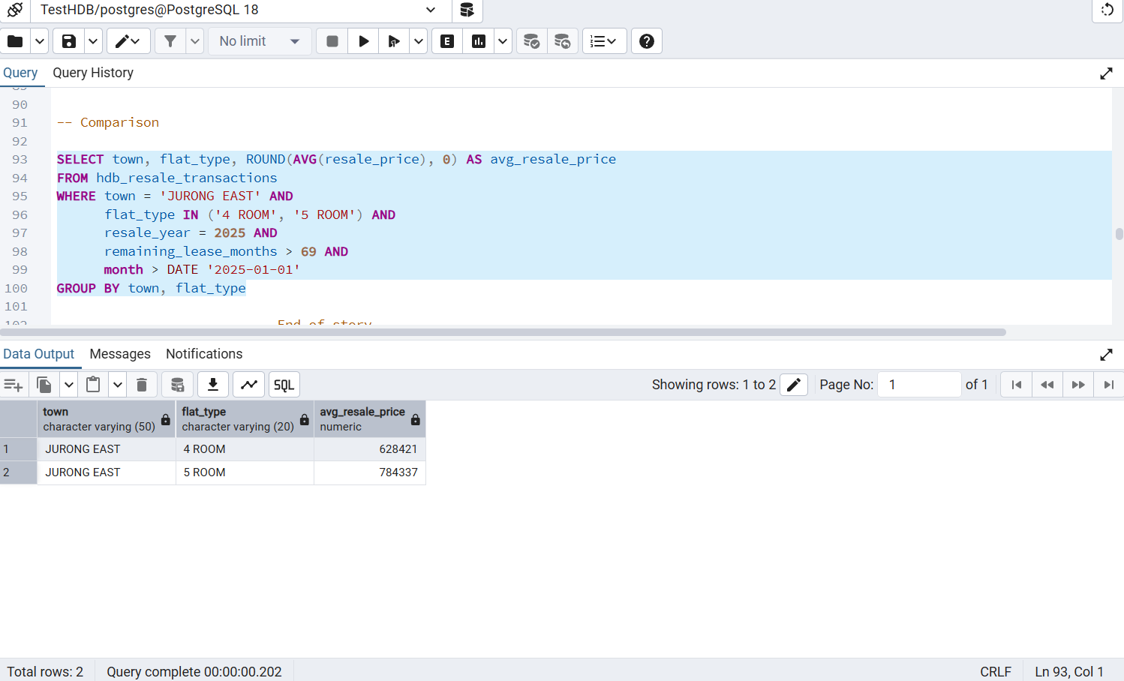

8.4 Observations

Special observations about the data gathered though the 3 scenarios of data integrity, EDA and analytical queries in the form of a story.
    - Average price of 4 room flats in Clementi in 2025 is about 40% higher than in Jurong East though it is just 1 mrt stop away (e.g., older lease trends, price growth)
    - Jurong East might catch up to Clementi in time with Jurong Lake District Transformation and 2 mrt lines coming up (JRL and CRL) as Clementi is a more mature estate than Jurong East
    - The top 3 estates with the the highest increase in resale price from MOP flats (most recent to 1 year ago) are Sebawang, Bukit Batok and Punggol (all 4 Room) with all 3 registering at least a 40% increase in 1 year! These estates are no longer considered too far from city centre.
    - This could be because Sebawang and Bukit Batok are designated to have more assisted living options and facilities for seniors.
    - No of yearly transactions logged for 2025 till end Nov has dropped by 16% since last year and it is the lowest since 2020.
    - It shows the resale market is cooling and people are likely buying BTOs instead of resale or condos.
    - However, prices have been climbing in 2025 despite lesser transactions done which may suggest that prices may come down in 2026.

8.5 Final Takeaway Narrative
- Transforming data to include more data columns helps to provide deeper insight into a data set provided
- Provides relevant info that is easier to read, digest and compare compared to apps online ie property guru as there is too much information.
    - Usage of graphical illustration would likely make the data easier and quicker to comprehand however graphs in postgresql are too simple

9. PHASE 6 — FUTURE IMPROVEMENTS
1. Automate end to end ETL
Use Apache Airflow or GitHub Actions so the dataset refreshes monthly without manual steps.
2. Add a BI dashboard
Power BI can visualise
• Price distribution
• Lease decay vs price
• Town comparison
• Time series trends
A semantic model can be added later.
3. Expand SQL model
Introduce dimensional modelling:
• Fact table: resale transactions
• Dimensions: town, flat_type, date, region

10. Appendix
Data dictionary
Column Name | Type | Description
_id | Integer | Source-generated unique identifier from Data.gov.sg (retained for interim project).
month | Text | String in YYYY-MM-DD format in the clean CSV. This column is cast to DATE when loaded into PostgreSQL for time-based grouping.
town | Text | HDB town where the flat is located.
flat_type | Text | Type of HDB flat (e.g., 3 ROOM, 4 ROOM, EXECUTIVE).
block | Text | Block number of the resale unit.
street_name | Text | Street name of the resale unit.
storey_range | Text | Floor range of the unit (e.g., “10 TO 12”).
floor_area_sqm | Numeric | Size of the unit in square metres.
flat_model | Text | HDB flat model classification (e.g., Improved, New Generation, DBSS).
lease_commence_date | Integer | Year the flat’s lease commenced.
remaining_lease | Text | Raw remaining lease value (e.g., “62 years 05 months”).
resale_price | Numeric | Final transacted resale price.
resale_year | Integer | Year extracted from the month column.
resale_month | Integer | Month extracted from the month column.
resale_quarter | Integer | Integer (1–4) representing the quarter of the resale month.
remaining_lease_years | Numeric | Derived numeric remaining lease in years, rounded to the nearest whole year.
flat_age_years | Numeric | Derived flat age based on lease commencement year.
price_per_sqm | Numeric | Normalised price per square metre (resale_price / floor_area_sqm).
flat_age_category | Text | Grouped age classification: New (<10), Young (10–19), Middle-aged (20–29), Mature (30–39), Old (>39).
price_category | Text | Categorised resale price band: Low (<300k), Medium (300k–499k), High (500k–799k), Premium (>799k).
region | Text | Region classification for mapping towns to broader geographical zones (e.g., North, East, West, Central, Northeast).

